

## Audio Study

email: [arturbekker@ufl.edu](mailto:arturbekker@ufl.edu)

## Audio Study

email: arturbekker@ufl.edu

## Audio Study

email: arturbekker@ufl.edu

## Audio Study

email: arturbekker@ufl.edu

## Audio Study

email: arturbekker@ufl.edu

## Audio Study

email: [arturbekker@ufl.edu](mailto:arturbekker@ufl.edu)

## Audio Study

email: [arturbekker@ufl.edu](mailto:arturbekker@ufl.edu)

## Audio Study

email: [arturbekker@ufl.edu](mailto:arturbekker@ufl.edu)

## Audio Study

email: [arturbekker@ufl.edu](mailto:arturbekker@ufl.edu)

## Audio Study

email: [arturbekker@ufl.edu](mailto:arturbekker@ufl.edu)

# Participants Wanted

* Participants must be:
  + 18 years or older and a UF student
  + Possess normal hearing

for a 3D Audio Experiment

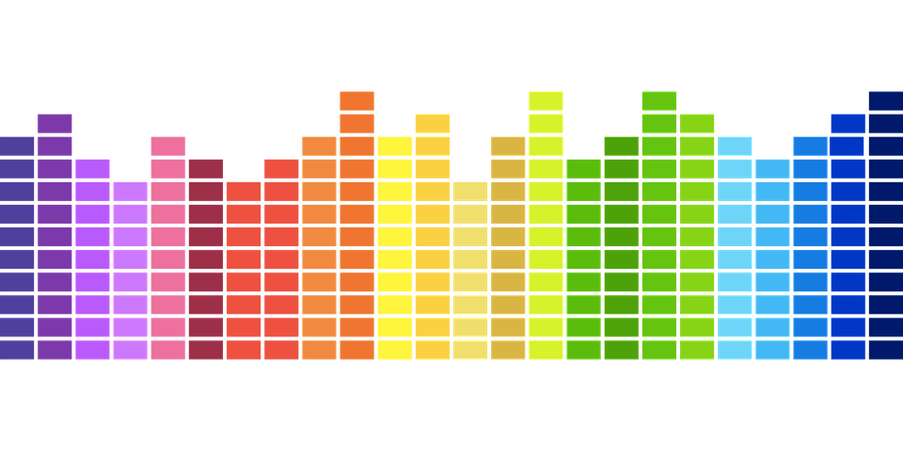

IRB **201800405**

Department of Computer & Information Science & Engineering, UF



* During the study you will listen to spatialized (3D) sounds and report on your experience.
* This sound is intended to emulate what you would hear walking through nature.
* Studies will be conducted in the CISE Department.
* This study does not include any payment or compensation
* For more information:
  + Email: arturbekker@ufl.edu